PLEASE READ!!

HELENA LABORATORIES
PROCEDURE DOWNLOAD END USER AGREEMENT

In response to customer requests, Helena is pleased to provide the text for procedural package inserts in a digital format editable for your use. The text for the procedure you requested begins on page three of this document. Helena procedures contain the content outlined in the NCCLS (GP2-A#) format, except in the order sequence required by FDA regulations. As the NCCLS format is a guideline, you may retain these procedures as developed by the manufacturer (adding your title/authorization page) or manipulate the text file to produce your own document, matching the NCCLS section order exactly, if preferred.

We also provide the procedure in an Adobe Acrobat PDF format for download at www.helena.com as a “MASTER” file copy. Below are the specifications and requirements for using these digital files. Following the specifications is the procedure major heading sequence as given in the FDA style. Where there is a difference in order, or other notation in the outline, this will be indicated in braces { }.

WHAT YOU NEED TO KNOW:

1) These files represent the most current revision level to date. Your current product inventory could contain a previous revision level of this procedure.

2) The Microsoft Word document provides the text only from the master procedure, in a single-column format.

- It may not contain any illustrations, graphics or captions that may be part of the master procedure included in the kit.

- The master procedure may have contained special formatting characters, such as subscripts, superscripts, degree symbols, mean symbols and Greek characters such as alpha, beta, gamma, etc. These symbols may or may not display properly on your desktop.

- The master procedures may also contain columns of tabbed data. Tab settings may or may not be displayed properly on your desktop.

3) The Adobe Acrobat PDF file provides a snapshot of the master procedure in a printable 8.5 x 11” format. It is provided to serve as a reference for accuracy.

4) By downloading this procedure, your institution is assuming responsibility for modification and usage.
HELENA LABORATORIES
PROCEDURE DOWNLOAD END USER AGREEMENT

HELENA LABORATORIES LABELING – Style/Format Outline

- PRODUCT {Test} NAME
- INTENDED USE and TEST TYPE (qualitative or qualitative)
- SUMMARY AND EXPLANATION
- PRINCIPLES OF THE PROCEDURE
{NCCLS lists SAMPLE COLLECTION/HANDLING next}
- REAGENTS (name/concentration; warnings/precautions; preparation; storage; environment; Purification/treatment; indications of instability)
- INSTRUMENTS required – Refer to Operator Manual (... for equipment for; use or function; Installation; Principles of operation; performance; Operating Instructions; Calibration* {*is next in order for NCCLS – also listed in “PROCEDURE”}’ precautions/limitations/hazards; Service and maintenance information
- SAMPLE COLLECTION/HANDLING
- PROCEDURE
{NCCLS lists QUALITY CONTROL (QC) next}
9) RESULTS (calculations, as applicable; etc.)
10) LIMITATIONS/NOTES/INTERFERENCES
11) EXPECTED VALUES
12) PERFORMANCE CHARACTERISTCS
13) BIBLIOGRAPHY (of pertinent references)
14) NAME AND PLACE OF BUSINESS OF MANUFACTURER
15) DATE OF ISSUANCE OF LABELING (instructions)

For Sales, Technical and Order Information, and Service Assistance,
call Helena Laboratories toll free at 1-800-231-5663.

Form 364
Helena Laboratories
1/2006 (Rev 3)

Hemoglobin Electrophoresis
Procedure

Helena’s Hemoglobin Electrophoresis Procedure, using cellulose acetate in alkaline buffer, is intended for the qualitative and quantitative determination of abnormal hemoglobins.

SUMMARY
Hemoglobins (Hb) are a group of proteins whose chief functions are to transport oxygen from the lungs to the tissues and carbon dioxide in the reverse direction. They are composed of polypeptide chains called globin, and iron protoporphyrin heme groups. A specific sequence of amino acids constitutes each of four polypeptide chains. Each normal hemoglobin molecule contains one pair of alpha and one pair of non-alpha chains. In normal adult hemoglobin (HbA), the non- alpha chains are called beta. The non-alpha chains of fetal hemoglobin are called gamma. A minor (3%) hemoglobin fraction called HbA2 contains alpha and delta chains. In a hereditary inhibition of globin chain synthesis called thalassemia, the non-alpha chains may aggregate to form HbH (β4) or Hb Bart’s (α4).
The major hemoglobin in the erythrocytes of the normal adult is HbA and there are small amounts of HbA2 and HbF. In addition, over 400 mutant hemoglobins are now known, some of which may cause serious clinical effects, especially in the homozygous state or in combination with another abnormal hemoglobin. Wintrobe1 divides the abnormalities of hemoglobin synthesis into three groups:
- Production of an abnormal protein molecule (e.g. sickle cell anemia)
- Reduction in the amount of normal protein synthesis (e.g. thalassemia)
- Developmental anomalies (e.g. hereditary persistence of fetal hemoglobin (HPFH)
The two mutant hemoglobins most commonly seen in the United States are HbS and HbC. Hb Lepore, HbE, HbG-Philadelphia, HbD- Los Angeles, and HbO-Arab may be seen less frequently.2
Electrophoresis is generally considered the best method for separating and identifying hemoglobinopathies. One protocol for hemoglobin electrophoresis involves the use of two systems.3-8 Initial electrophoresis is performed in alkaline buffers. Cellulose acetate is the major support medium used because it yields rapid separation of HbA, F, S and C and many other mutants with minimal preparation time. However, because of the electrophoretic similarity of many structurally different hemoglobins, the evaluation must be supplemented by a procedure that measures some other property. A simple procedure which confirms the identification of both HbS and HbC, as well as HbA, HbF and many other mutants, is citrate agar electrophoresis. This method is based on the complex interactions of the hemoglobin with the electrophoretic buffer (acid pH) and the agar support.
Electrophoresis is a simple procedure requiring only minute quantities of hemolysate to provide highly specific (but not absolute) confirmation of the presence of HbS, HbC and HbF as well as several other abnormal hemoglobins.

PRINCIPLE
Very small samples of hemolysates prepared from whole blood are applied to the Titan III® Cellulose Acetate Plate. The hemoglobins in the sample are separated by electrophoresis using an alkaline buffer (pH 8.2-8.6), and are stained with Ponceau S Stain. The patterns are scanned on a scanning densitometer, and the relative percent of each band determined.

REAGENTS
- Supre-Heme® Buffer (Cat. No. 5802)
Ingredients: The buffer contains Tris-EDTA and boric acid.

WARNING: FOR IN-VITRO DIAGNOSTIC USE ONLY. NEVER PIPETTE
BY MOUTH. DO NOT INGEST. Ingestion of sufficient quantities of boric acid and EDTA can be toxic.
Preparation for Use: Dissolve one package of buffer in 980 mL deionized water. The buffer is ready for use when all material is dissolved and completely mixed.
Storage and Stability: The packaged buffer should be stored at 15 to 30°C and is stable until the expiration date indicated on the package and box. The buffer solution is stable two months when stored at 15 to 30°C.

Signs of Deterioration: Do not use packaged buffer if the material shows signs of dampness or discoloration. Discard the buffer solution if it shows signs of bacterial contamination.

Hemolysate Reagent (Cat. No. 5125)
Ingredients: The reagent contains 0.005 M EDTA in deionized water with 0.07% potassium cyanide added as a preservative.

WARNING: FOR IN-VITRO DIAGNOSTIC USE ONLY. DO NOT PIPETTE
BY MOUTH. The reagent contains a small amount of potassium cyanide.
Preparation for Use: The reagent is ready to use as packaged.
Storage and Stability: The reagent should be stored at 15 to 30°C and is stable until the expiration date indicated on the bottle.
Signs of Deterioration: The reagent should be clear and colorless.

Ponceau S Stain (Cat. No. 5526)
Ingredients: The reconstituted stain is 0.5% (w/v) Ponceau S in an aqueous solution of 10% (w/v) sulfosalicylic acid.

WARNING: FOR IN-VITRO DIAGNOSTIC USE. DO NOT INGEST HARMFUL IF SWALLOWED.
Preparation for Use: Dissolve one vial of stain in 1 L of deionized water. Storage and Stability: The stain should be stored at 15 to 30°C and is stable until the expiration date indicated on the container. It may be stored in the bottle or in a tightly closed staining dish and may be reused multiple times if properly stored.
Signs of Deterioration: Do not use the stain solution if excessive evaporation occurs, or if large amounts of precipitate appear.

Clear Aid (Cat. No. 5005)
Ingredients: The reagent contains polyethylene glycol.

WARNING: FOR IN-VITRO DIAGNOSTIC USE. DO NOT INGEST.
Preparation for Use: Clear Aid is used as the clearing solution which is prepared as follows:
30 parts glacial acetic acid 70 parts absolute methanol 4 parts Clear Aid
Storage and Stability: Store the prepared clearing solution at 15 to 30°C in a tightly closed container to prevent evaporation of the methanol. When evaporation occurs, the plates may delaminate. Water contamination from over-use of the clearing solution will cause the plate to be cloudy. The reagent is stable until the expiration date indicated on the bottle.
Signs of Deterioration: Clear Aid should be a clear, colorless liquid, although it may appear cloudy when cold. Do not use the material upon evidence of gross contamination or discoloration. Discard the prepared Clear Aid if plates appear cloudy after the clearing procedure.
- PermaClear Solution (Cat. No. 4950) - Optional Ingredients: N-methyl pyrrolidinone and PEG.

WARNING: FOR IN-VITRO DIAGNOSTIC USE - IRRITANT - DO NOT
PIPPETTE BY MOUTH. VAPOR HARMFUL. In case of contact, flush affected areas with copious amounts of water. Get immediate attention for eyes.
Preparation for Use: Add 55 mL PermaClear to 45 mL deionized water and mix well.
Storage and Stability: PermaClear should be stored at 15 to 30°C and is stable until the expiration date on the bottle.
Signs of Deterioration: Discard the PermaClear Solution if the plates turn white and do not clear as expected.
- Titan III-H Plates (Cat. No. 3021, 3022) Ingredients: Cellulose acetate plates. WARNING: FOR IN-VITRO DIAGNOSTIC USE.
Preparation for Use: The plates are ready for use as packaged.
Storage and Stability: The plates should be stored at 15 to 30°C and are stable indefinitely.

INSTRUMENTS
Any high quality scanning densitometer capable of scanning a cleared cellulose acetate plate at 525 nm may be used. Recommended is the Helena Quickscan 2000.

SPECIMEN COLLECTION AND HANDLING
Specimen: Whole blood collected in tubes containing EDTA or heparin is the specimen of choice.
Specimen Preparation: Specimen hemolysates are prepared as outlined in the STEP-BY-STEP METHOD.
Specimen Storage and Stability: Whole blood samples may be stored up to one week at 2 to 6°C.

PROCEDURE
Materials Provided: The following materials needed for the procedure are available from Helena Laboratories.

Hardware Cat. No.
lowering a rack of plates into the buffer.
The same soaking buffer may be used for soaking up to 12 plates or for approximately one week if stored tightly closed. If used for a prolonged period, residual solvents from the plates may build up in the buffer and cause poor separation of the proteins or, evaporation may cause greater buffer concentration.

Preparation of Zip Zone® Chamber
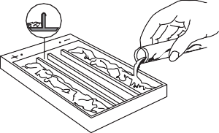
  - Pour approximately 100 mL of Supre-Heme® Buffer into each of the outer sections of the Zip Zone®Chamber.
  - Wet two chamber wicks in the buffer and drape one over each support bridge being sure it makes contact with the buffer and that there are no air bubbles under the wicks.
Super Z-12 Applicator Kit (12 samples) Super Z Applicator Kit (8 samples) Microdispenser and Tubes | 4093  4088  6008 | 3. Cover the chamber to prevent buffer  wicks after use.
1000 Staining Set | 5122 | C. Sample Preparation and Application
Bufferizer | 5093 | 1. Prepare a hemolysate of the patient samples as follows:
Titan Plus Power Supply  Consumables | 1504 | a. Using whole blood: Add 1 part whole blood to 3 parts Hemolysate
Titan® III-H Cellulose Acetate (94 mm x 76 mm)-12 samples | 3021 | Reagent. Mix well and allow to stand 5 minutes.
Titan® Cellulose Acetate (76 mm x 60 mm)-8 samples | 3022 | Hemolysate Reagent. Mix well and allow to stand 5 minutes. NOTE:
Supre-Heme Buffer | 5802 | If removal of denatured hemoglobins from the sample is deemed
Hemo AFSA Control  2  Hemo AA Control  2 | 5330  5328 | necessary, see the Alternate Sample Preparation Procedure.
Hemo AFSC Control | 5331 | or 5 μL of the Hemo Controls into the
Hemo ASA Control  2 | 5329 | wells of the Sample Well Plates using
Hemolysate Reagent | 5125 | the Microdispenser. Do not prepare a
Ponceau S | 5526 | hemolysate of the Hemo Controls.
Clear Aid | 5005 | 3. To prevent evaporation, cover the Sample
Titan Blotter Pads | 5034 | Well Plate with a glass slide, if the samples
Zip Zone® Prep | 5090 | are not used within 2 minutes.
Titan Plastic Envelopes | 5052 | 4. Prime the applicator by depressing the tips
Helena Marker | 5000 | into the sample wells 3 or 4 times. Apply this
Identification Labels | 5006 | loading to a piece of blotter paper. Priming the applicator makes the second
Zip Zone® Chamber Wicks | 5081 | loading much more uniform. Do not load applicator again at this point, but
Glue Stick | 5002 | proceed quickly to the next step.
PermaClear | 4950

evaporation. Discard the buffer and

b. Using packed cells: Mix 1 part packed red blood cells to 6 parts

2. Place 5 μL of the patient hemolysates

Materials Needed, but not Provided:
Glacial acetic acid Absolute methanol
5% acetic acid – Mix 5 parts of glacial acetic acid with 95 parts deionized water.
SUMMARY OF CONDITIONS
Plate ............................................................................................ Titan® III-H
Buffer..............................Supre-Heme® dissolved in 980 mL deionized water Soaking Time for Plates .................................................................5 minutes
Sample Size (hemolysate)......................................................................5 µL
Number of Applications .................................................................... One (1)
Electrophoresis Time................................................................... 25 minutes
Voltage ........................................................................................... 350 volts
Staining Time (total) .....................................................................20 minutes
Drying Time.....................................................................10 minutes at 56°C
Scanning Wavelength ........................................................................525 nm

STEP BY STEP METHOD
- Preparation of the Titan® III-H Plate
  - Dissolve one package Supre-Heme® Buffer in 980 mL deionized water.
  - Properly code the required number of Titan® III-H Plates by marking on the glossy hard side with a marker.
  - Soak the required number of plates in Supre-Heme® Buffer for 5 minutes. The plates should be soaked in the bufferizer according to the instructions provided. Alternately, the plates may be wetted by slowly and uniformly

- Remove the wetted Titan® III Plate from the buffer with the fingertips and blot once firmly between two blotters. Place the plate in the aligning base, cellulose acetate side up,
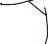aligning the top edge of the plate with the black scribe line marked “CATHODE APPLICATION”.
The identification mark should be
CATHODE APPLICATION
CENTER APPLICATIONHELENA LABORATORIES
aligned with sample No. 1. Before placing the plate in the aligning base, place a drop of water or buffer on the center of the aligning base. This prevents the plate from shifting during the sample application.

- 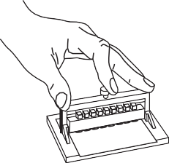Apply the sample to the plate by depressing the applicator tips into the sample well 3 or 4 times and promptly transferring the applicator to the aligning base. Press the button down and hold it 5 seconds.
5 6 7 8
1 2 3 4
5 6 7 8
1 2 3 4

Alternate Sample Preparation Procedure:
If removal of denatured hemoglobins from the sample is deemed necessary, perform the following steps:
  - Centrifuge the blood sample at 3500 RPM for 5 minutes.
  - Remove the plasma from the sample and wash the red blood cells in 0.85% saline (v/v) three times. After each wash, centrifuge the cells for 10 minutes at 3500 RPM.
  - Add 1 volume deionized water and 1/4 volume toluene (or carbon tetrachloride) to the washed red cells. Vortex at high speed for one minute. Centrifuge the samples at 3500 RPM for 10 minutes.
  - If toluene is used, the top layer in the tube will contain cell stroma and should be removed with a capillary pipette before proceeding to the next step. The clear middle layer contains the desired sample. If carbon tetrachloride is used, all red cell waste material will be contained in the bottom of the tube after centrifugation.
  - Filter the clear red solution through two layers of Whatman #1 filter paper.

Electrophoresis of Sample Plate
  - Quickly place the plate in the elecrophoresis chamber, cellulose acetate side down, such that the sample end is toward the cathodic(-) side of the chamber. Place a weight (glass slide, etc.) on the plate to insure contact with the wicks.
  - Place the cover on the chamber, and electrophorese the plate for 25 minutes at 350 volts.

Staining the Hemoglobin Bands
  - Remove the plates from the electrophoresis chamber and stain in Ponceau S for 5 minutes.
  - Destain in 3 successive washes of 5% acetic acid. Allow the plates to stay in each wash 2 minutes or until the background is white.
  - The plates may be dried and stored for a permanent record at this point. If a transparent background is desired for densitometry, proceed to the next step.

If using Clear Aid Solution:
  - Dehydrate, by washing the plate twice in absolute methanol, for two minutes each wash. Allow the plate to drain for 5-10 seconds before placing in the next solution.
  - Place the plate into the Clear Aid solution for 5-10 minutes.
  - Drain off excess solution. Then place the plate, acetate side up, onto a blotter, and into an I. O. D., Micro-Hood, or other drying oven at 50-60°C for 15 minutes or until dry.

If using PermaClear Solution:
- Place the plate(s) into the diluted PermaClear clearing solution for 2 minutes.
- Drain off excess solution by holding plate(s) vertically for 1 minute. Then place the plate, acetate side up, onto a blotter, and into an I. O. D., or other

Stability of End Product: The dried plates are stable for an indefinite period of time, and may be stored in Titan Plastic Envelopes.
Calibration: A calibration curve is not necessary because relative concentration of the bands is the only parameter determined.
Quality Control: Four controls for hemoglobin electrophoresis are available from Helena Laboratories: AA2 Hemo Control (Cat. No. 5328), ASA2 Hemo Control (Cat. No. 5329), AFSA2 Hemo Control (Cat. No.5330), and AFSC Hemo Control (Cat.
No. 5331). The controls should be used as markers for the identification of the
hemoglobin bands, and they may be quantitated for verification of the accuracy of the procedure. Refer to the package insert provided with the controls for assay values and migration patterns. Use at least one of these controls on each plate run.

RESULTS
Figures 1 illustrates how the combination of cellulose acetate and citrate agar electrophoresis can be used in tandem for the identification of hemoglobins. Figure 2 lists the relative mobilities of various hemoglobin mutants on cellulose acetate and citrate agar plates.
Calculation of Unknown: The QuickScan 2000 will automatically print the relative percent and the absolute values for each band. Alternately, the relative percent of each band can be calculated manually by referring to the Operator’s Manual provided with the densitometer. The relative percent of each band is calculated by the following formula:
No. Integration Units of the Band x 100 = Relative Percent Total Integration of Units of the Band

Relative Percent x Total = Absolute Value
of the Band Hemoglobin of Protein per band

LIMITATIONS
Some abnormal hemoglobins have similar electrophoretic mobilities and must be differentiated by other methodologies.
Further testing required:
- Citrate agar electrophoresis may be a necessary follow-up test for confirmation of abnormal hemoglobins detected on cellulose acetate.
- Isoelectric focusing, high performance liquid chromatography, globin chain analysis (both acid and alkaline) and structural studies may be necessary in order to positively identify some of the more rare hemoglobins.
- Low levels of HbF (1-10%) may be accurately quantitated using any commercially available HbF method.

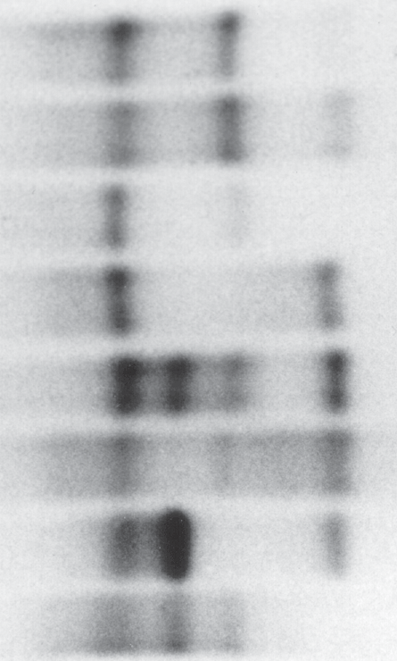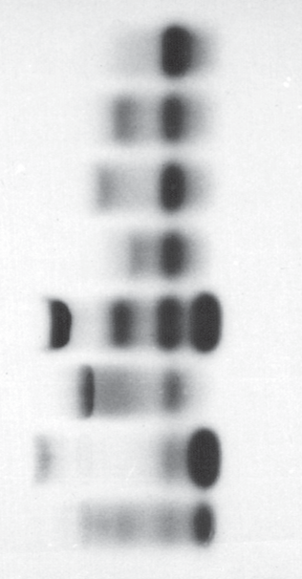(+) Cellulose Acetate (-) (+) Citrate Agar (-)
AD Los Angeles AS-G Philadelphia A Hasharon
AO-Arab

AFSC Control AE
FAC FAS

drying oven at 50-60°C for 15 minutes or until dry.

Evaluation of the Hemoglobin Bands
  - Qualitative evaluation: The hemoglobin plates may be inspected visually for the presence of abnormal hemoglobin bands. The Helena Hemo Controls
A F S A2 C D C
G E
O
S A F
A2 D E G

provide a marker for band identification.
  - Quantitative evaluation: Determine the relative percent of each hemglobin band by scanning the cleared and dried plates in the densitometer using a 525 nm filter.
Application Point Methemoglobin
Figure 1. Electrophoretic Mobilities of Hemoglobins on Titan® III Cellulose Acetate and on Titan® IV Citrate Agar.

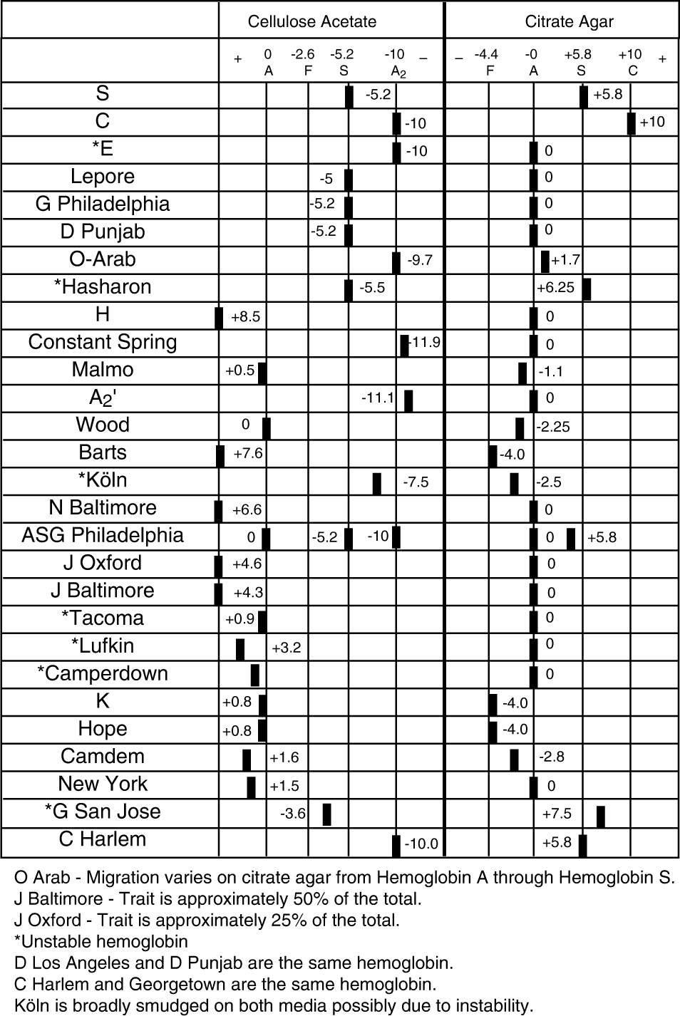
Figure 2. Relative Electrophoretic Mobilities of Hemoglobins on Celulose Acetate and Citrate Agar.11

REFERENCE VALUES
At birth, the majority of hemoglobin in the erythrocytes of the normal individual is fetal hemoglobin, HbF. Some of the major adult hemoglobin, HbA, and a small amount of HbA2, are also present. At the end of the first year of life and through adulthood, the major hemoglobin present is HbA with up to 3.5% HbA2 and less than 2% HbF.

INTERPRETATION OF RESULTS
Most hemoglobin variants cause no discernible clinical symptoms, so are of interest primarily to research scientists. Variants are clinically important when their presence leads to sickling disorders, thalassemia syndromes, life long cyanosis, hemolytic anemias or erythrocytosis, or if the heterozygote is of sufficient prevalence to warrant genetic counseling. The combinations of HbS-S, HbS-D-Los Angeles, and HbS-O Arab lead to serious sickling disorders.2 Several variants including HbH, HbE-Fort Worth and Hb Lepore cause a thalassemic blood picture.2 The two variant hemoglobins of greatest importance in the U.S., in terms of frequency and pathology are HbS and HbC.2 Sickle cell anemia (HbSS) is a cruel and potentially lethal disease. It first manifests itself at about 5-6 months of age. The clinical course presents agonizing episodes of pain and temperature elevations with anemia, listlessness, lethargy, and infarct in virtually all organs of the body. The individual with homozygous HbCC suffers mild hemolytic anemia which is attributed to the precipitation or crystallization of HbC within the erythrocytes. Cases of HbSC disease are characterized by hemolytic anemia that is milder than sickle-cell anemia. The thalassemias are a group of hemoglobin disorders characterized by hypochromia andmicrocytosis due to the diminished synthesis of one globin chain (the α or β) while synthesis of the other chain proceeds normally.9,10 This unbalanced synthesis results in unstable globin chains. These precipitate within the red cell, forming inclusion bodies that shorten the lifespan of the cell. In α-thalassemias, the α-chains are diminished or absent. In β-thalassemia, the β-chains are affected.
Another quantitative disorder of hemoglobin synthesis, hereditary persistent fetal hemoglobin (HPFH), represents a genetic failure of the mechanisms that turn off gamma chain synthesis at about four months after birth, which results in a continued high percentage of HbF. It is a more benign condition than the true thalassemias, and persons homozygous for HPFH have normal development, are asymptomatic and have no anemia.10
Shaded areas indicate that the text has been modified, added or deleted.
The most common hemoglobin abnormalities: Sickle Cell Trait
This is a heterozygous state showing HbA and HbS, and a normal amount of HbA2 on cellulose acetate. Results on citrate agar show hemoglobins in the HbA and HbS migratory positions (zones).
Sickle Cell Anemia
This is a homozygous state showing almost exclusively HbS, although a small amount of HbF may also be present.
Sickle-C Disease
This is a heterozygous state demonstrating HbS and HbC. Sickle Cell-Thalassemia Disease
This condition shows HbA, HbF, HbS, and HbA2. In Sickle Cell β-Thalassemia HbA is absent.
Thalassemia-C Disease
This condition shows HbA, HbF and HbC. C Disease
This is a homozygous state showing almost exclusively HbC. Thalassemia Major
This condition shows HbF, HbA and HbA2.

BIBLIOGRAPHY
- Wintrobe, Maxwell M. Clinical Hematology 6th Edition, Lea and Febiger, Philadelphia, 1967.
- Fairbanks, V.F., Diagnostic Medicine, Nov/Dec., 53-58, 1980.
- Schneider, R.G., et al., Laboratory Identification of the Hemoglobins, Lab Management, August, 29-43, 1981.
- Center for Disease Control, Laboratory Methods for Detecting Hemoglobinopathies, U.S. Department of Health and Human Services/Public Health Service, 1984.
- Schneider, R.G., Methods for Detection of Hemoglobin Variants and Hemoglobinopathies in the Routine Clinical Laboratory, CRC Critical Reviews in Clinical Laboratory Sciences, 1978.
- Schneider, R.G. et al., Abnormal Hemoglobins in a Quarter Million People, Blood, 48(5):629-637, 1976.
- Huisman, T.H.J. and Schroeder, W.A., New Aspects of the Structure, Function, and Synthesis of Hemoglobins, CRC Press,Cleveland, 1971.
- Schmidt, R.M., et al., The Detection of Hemoglobinopathies, CRC Press, Cleveland 1974.
- Weatherall, D.J. and Clegg, J.B., The Thalassaemia Syndromes, Blackwell Scientific Publications, Oxford, 1972.
- Lehman, H. and Huntsman, R.G., Man’s Haemoglobins, J.B.Lippincott Co., Philadelphia, 1974.
- Personal communication from Dr. Virgil Fairbanks.

For Sales and Order Information, and Technical or Service Assistance, call 800-231-5663 toll free.
Helena Laboratories warrants its products to meet our published specifications and to be free from defects in materials and workmanship. Helena’s liability under this contract or otherwise shall be limited to replacement or refund of any amount not to exceed the purchase price attributable to the goods as to which such claim is made. These alternatives shall be buyer’s exclusive remedies.
In no case will Helena Laboratories be liable for consequential damages even if Helena has been advised as to the possibility of such damages. The foregoing warranties are in lieu of all warranties expressed or implied including, but not limited to, the implied warranties of merchantability and fitness for a particular purpose.

Pro. 15 6/17(7)

